**AVR128DB48 Arduino boards**

* For using AVR128DB48 boards from Anton do:
* Add URL in Preferences: http://drazzy.com/package_drazzy.com_index.json
* Install DxCore ver. 1.3.2 in board manager

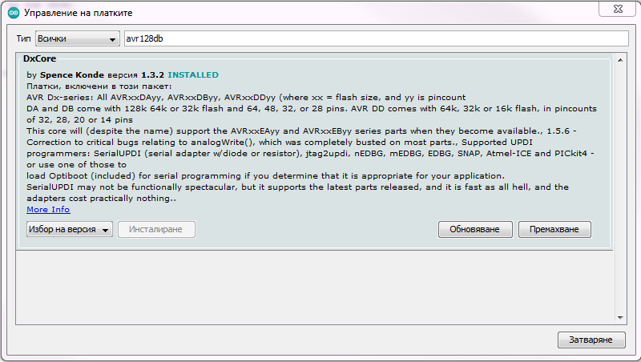

* Connect CP2102 USB to UART Bridge to Windows PC
* Install CP2102 USB driver if needed and verify the port: COM10 for example

**UPDI programmer (to burn bootloader)**

* Connect CP2102 USB to UART Bridge to the board
  + Rx ← 4.7k res. → Tx → AVR128DB48 UPDI (pin 41),
  + DTR → 200nF → RST (p. 40), GND, VCC (3.3V)
* Programmer: "Serial Port + 4.7k Resistor (pyupdi style)"
* Usage: Tools → Burn Bootloader
* Usage: Sketch → Upload Using Programmer

**Regular serial programmer**

* Connect CP2102 USB to UART Bridge to the board
  + CP2102/TTL-232R Tx → AVR128DB48 Rx0 (p. 45)
  + CP2102/TTL-232R Rx ← AVR128DB48 Tx0 (p. 44)
  + DTR → 200nF → RST (p. 40), GND, VCC (3.3V)
* Usage: Sketch → Upload

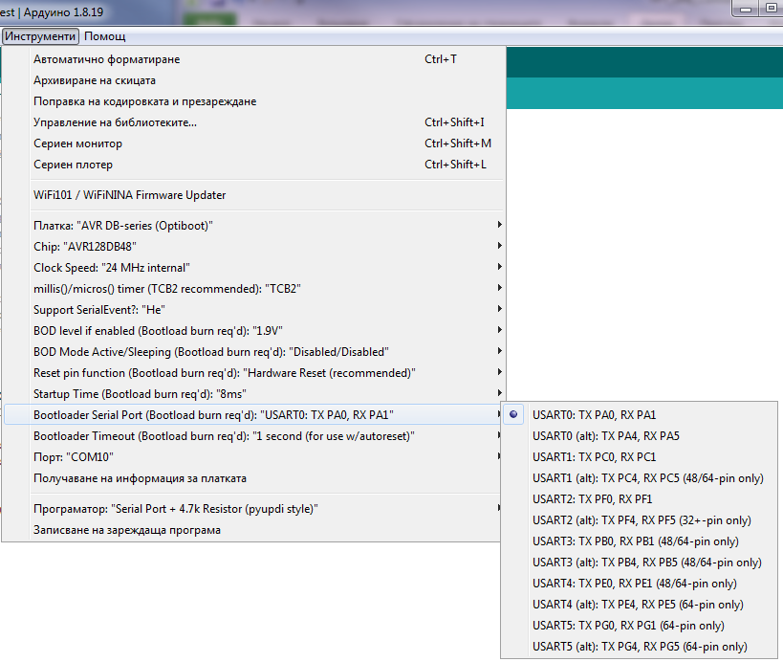

Bootloader serial port could be USART2 (alt), but using USART0 the PC COM port for both programming and serial communication with the sketch will be the same.

**“Blinking LED” test for avr128db48**

void setup() {

// PIN_PC3 for avr128db48

// may be different for other boards!

pinMode(17, OUTPUT);

}

void loop() {

digitalWrite(17, 1);

delay(100);

digitalWrite(17, 0);

delay(100);

}

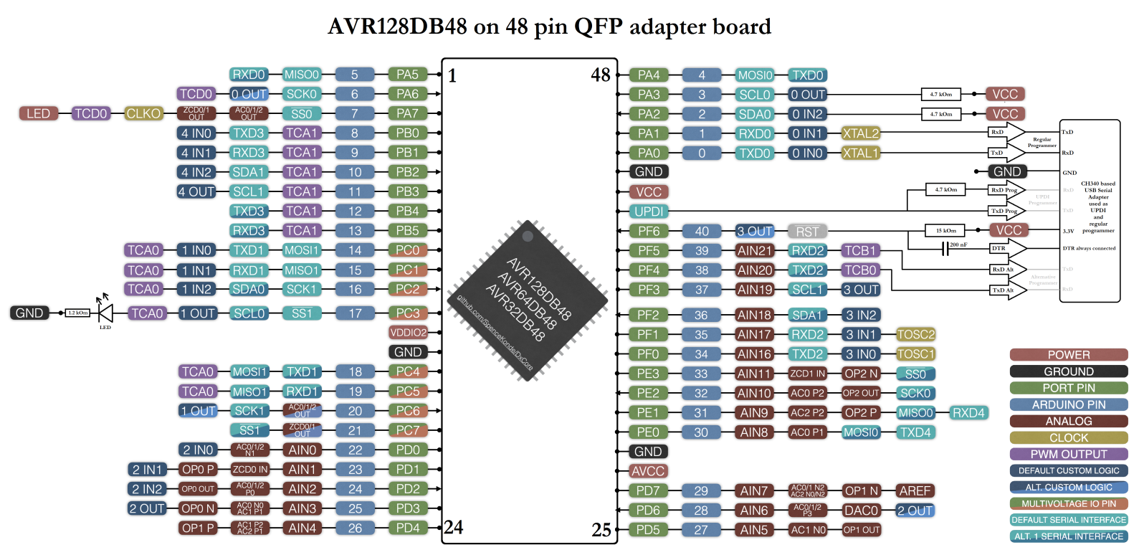

**Other boards notes:**

* Arduino UNO – install windows driver for USB-Serial CH340 adapter,
* Olimexino Nano – install windows driver for Arduino Leonardo compatible boards,
* Set in Tools → Board → Arduino AVR Boards → Arduino UNO or Arduino Leonardo respectively,
* Set in Tools → Port → corresponding COM port,
* LED pin may be different for different boards – change it in “Blinking LED” test sketch.

**Connection setup for 3.2” 240x320 pixels TFT display with SPI interface**

|  |  |  |  |  |  |  |
| --- | --- | --- | --- | --- | --- | --- |
|  | **Display Pin** | **Arduino UNO ATMega328** | **Optiboot AVR128DB48** | **Olimexino-Nano pin** | **Atmega32u4 pin** | **Description** |
| 1 | VCC | VCC-3.3V | VCC-3.3V | VCC-3.3V | VCC-3.3V | 3.3V power input (do not connect to 5V) |
| 2 | GND | GND | GND | GND | GND | GND |
| 3 | CS | D10 | 0,#SS, PA7 | D13 | PC7/ICP3/CLK0/OC4A | LCD chip select signal, low level enable |
| 4 | RESET | D8 | PA2 (0,SDA) | D4 | PD4/ICP1/ADC8 | LCD reset signal, low level reset |
| 5 | DC/RS | D9 | PA3 (0,SCL) | D11 | PB7/PCINT7/OC0A/OC1C/#RTS | LCD register / data selection signal, high level: register, low level: data |
| 6 | SDI(MOSI) | D11 | 0,MOSI, PA4 | D16 | PB2/PDI/PCINT2/MOSI | SPI bus write data signal |
| 7 | SCK | D13 | 0,SCK, PA6 | D15 | PB1/PCINT1/SCLK | SPI bus clock signal |
| 8 | LED | VCC-5V | VCC-5V | VCC-5V | VCC-5V | Backlight control, high level lighting, if not controlled, connect 5V for always bright |
| 9 | SDO(MISO) | D12 | 0,MISO, PA5 | D14 | PB3/PDO/PCINT3/MISO | SPI bus read data signal, if you do not need to the read function, you cannot connect it |

**All 3 boards are connected to 3.2”SPI TFT display and running Unified graphic test**

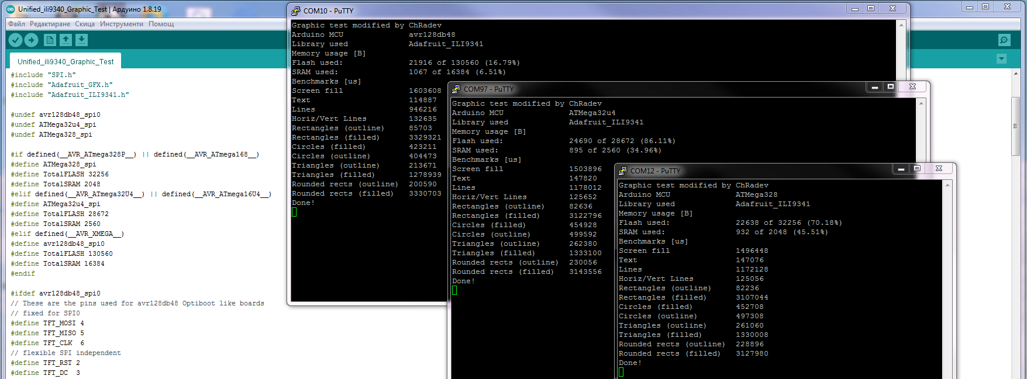  
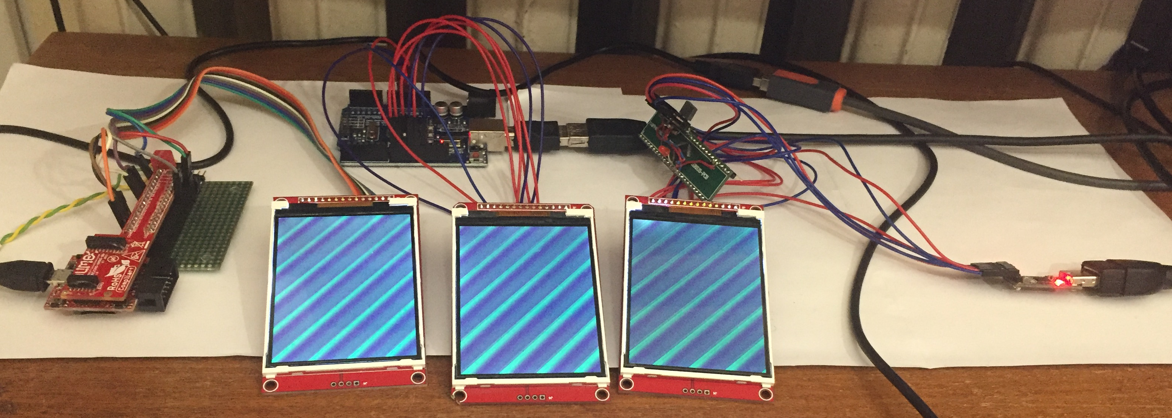  
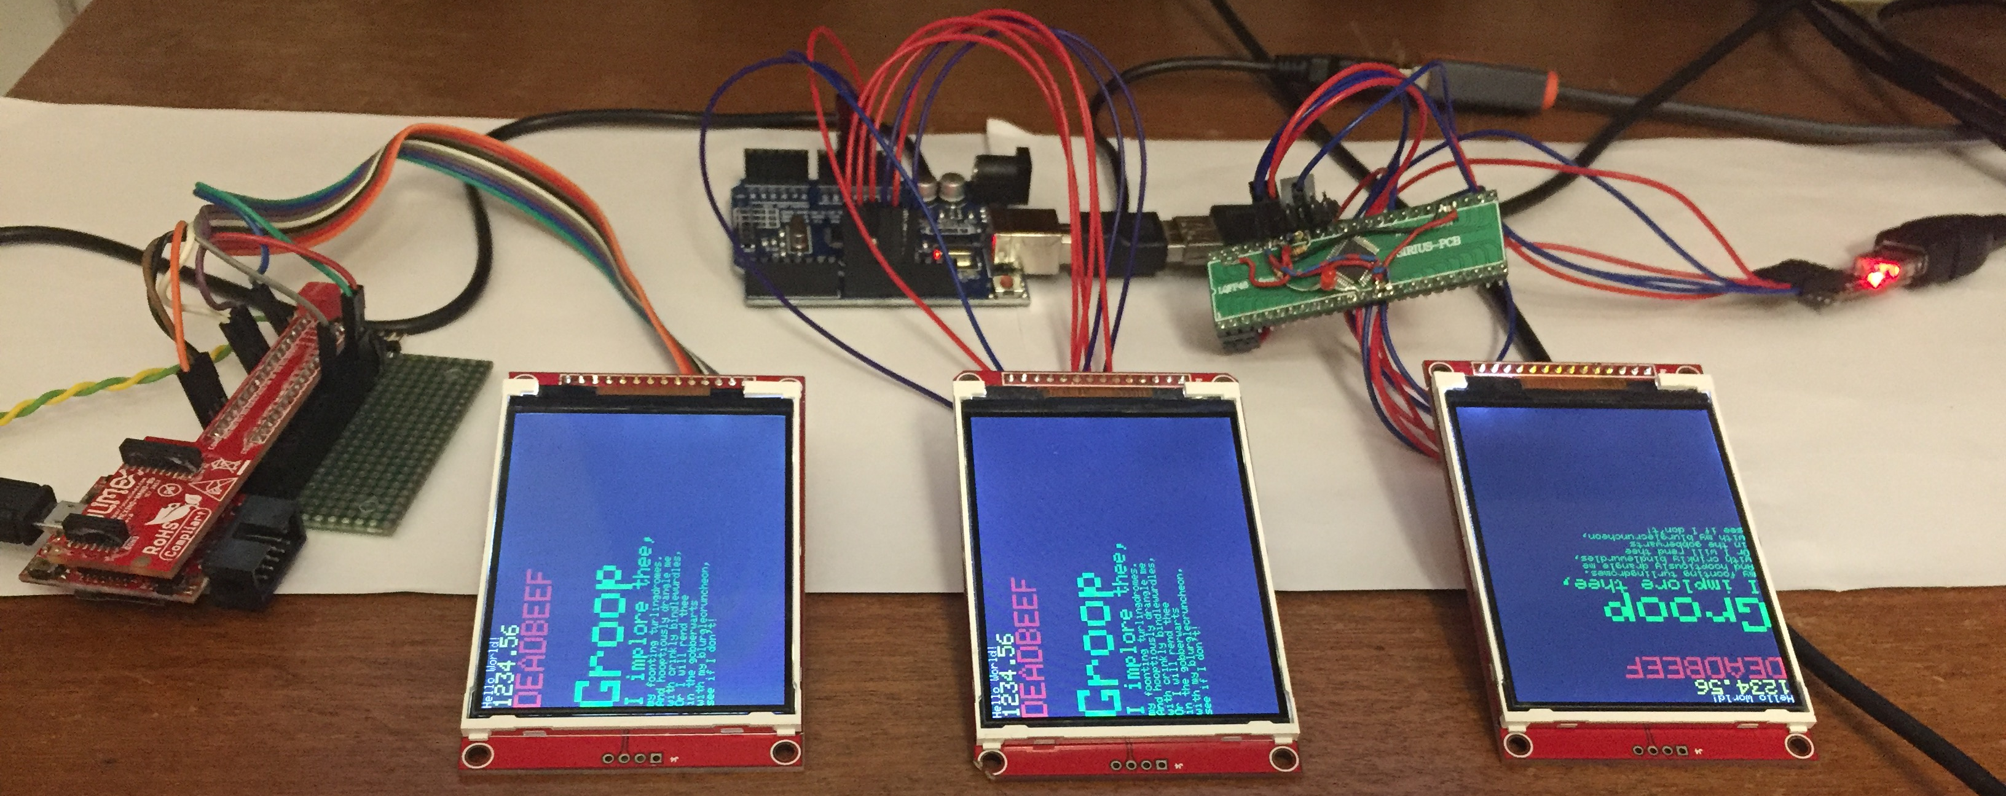  
 Olimexino Nano (ATMega32U4) Arduino UNO (ATMega328) Optiboot like (AVR128FB48)

**Benchmark of unified graphic and scroll tests built on Adafruit_ILI9341 and TFT_ ILI9341 libraries**

|  |  |  |  |  |  |  |  |  |  |
| --- | --- | --- | --- | --- | --- | --- | --- | --- | --- |
| **Arduino board / MCU** | **UNO / ATMega328** | | | **Leonardo / ATMega32u4** | | | **Optiboot / avr128db48** | | |
| **ILI9341 Library used** | **Adafruit** | **TFT** | **Speed up** | **Adafruit** | **TFT** | **Speed up** | **Adafruit** | **TFT** | **Speed up** |
| **Memory usage [B]** |  |  |  |  |  |  |  |  |  |
| **Flash used Flash total percentage** | 23,736 of 32,256 (73.59%) | 21,870 of 32,256 (67.80%) |  | 25,874 of 28,672 (90.24%) | 23,992 of 28,672 (83.68%) |  | 24,354 of 130,560 (18.65%) |  |  |
| **SRAM used SRAM total percentage** | 950 of 2,048 (46.39%) | 746 of 2,048 (36.43%) |  | 915 of 2,560 (35.74%) | 711 of 2,560 (27.77%) |  | 1,087 of 16,384 (6.63%) |  |  |
| **Benchmarks [us]** |  |  |  |  |  |  |  |  |  |
| **Screen fill** | 1,496,456 | 870,220 | 1.720 | 1,503,900 | 874,600 | 1.720 | 1,603,604 |  |  |
| **Text** | 147,088 | 60,416 | 2.435 | 147,820 | 60,724 | 2.434 | 114,885 |  |  |
| **Lines** | 1,172,116 | 242,732 | 4.829 | 1,178,004 | 243,988 | 4.828 | 946,199 |  |  |
| **Horiz/Vert Lines** | 125,064 | 71,336 | 1.753 | 125,656 | 71,696 | 1.753 | 132,637 |  |  |
| **Rectangles (outline)** | 82,228 | 45,844 | 1.794 | 82,632 | 46,076 | 1.793 | 85,703 |  |  |
| **Rectangles (filled)** | 3,107,060 | 1,807,436 | 1.719 | 3,122,844 | 1,816,740 | 1.719 | 3,329,307 |  |  |
| **Circles (filled)** | 452,728 | 284,064 | 1.594 | 454,916 | 285,536 | 1.593 | 423,221 |  |  |
| **Circles (outline)** | 497,252 | 135,580 | 3.668 | 499,604 | 136,148 | 3.670 | 404,412 |  |  |
| **Triangles (outline)** | 261,056 | 59,496 | 4.388 | 262,392 | 59,808 | 4.387 | 213,681 |  |  |
| **Triangles (filled)** | 1,330,720 | 694,456 | 1.916 | 1,337,200 | 698,032 | 1.916 | 1,279,412 |  |  |
| **Rounded rects (outline)** | 228,892 | 100,004 | 2.289 | 230,024 | 100,532 | 2.288 | 200,582 |  |  |
| **Rounded rects (filled)** | 3,127,968 | 1,976,936 | 1.582 | 3,143,588 | 1,987,180 | 1.582 | 3,330,751 |  |  |
| **Fill screen by pixels** | 3,369,992 | 918,732 | 3.668 | 3,387,308 | 923,492 | 3.668 | 2,964,859 |  |  |
| **Fill screen by bitmaps** | 528,576 | 855,088 | 0.618 | 531,112 | 859,520 | 0.618 | 453,099 |  |  |
| **Scroll and fill screen** | 532,988 | 855,696 | 0.623 | 535,808 | 860,132 | 0.623 | 457,946 |  |  |

**Notes:**

* Memory usage numbers are as reported in runtime and slightly different than one reported by the compiler;
* Preparing of the data for filling the screen by pixels or bitmaps are made to be as fast as possible;
* Speed up figure means the operation is that many times faster.